HUTTON PLAYGROUP
Registered charity no.1089042

Hutton Village Hall, Moor Lane, Hutton, Preston PR4 5SE
Tel: 01772 612806

Hutton Playgroup is a friendly, community based group managed by parents.
Welcome to Hutton Playgroup and thank you for registering your child with us.
We know how important your child is and aim to deliver the highest quality of care and education to help them to achieve their best.
This document aims to provide you with an introduction to Hutton Playgroup, our routines, our approach to supporting your child’s learning and development and how we aim to work together with you to best meet your child’s individual needs.
Our setting aims to:
- provide high quality care and education for children
- work in partnership with parents to help children to learn and develop
- add to the life and well-being of the local community
- offer children and their parents a service that promotes equality and values diversity
Parents
You are regarded as members of our setting who have full participatory rights. These include a right to be:
- valued and respected
- kept informed
- consulted
- involved
- included at all levels
Children's development and learning
We aim to ensure that each child:
- is in a safe and stimulating environment
- is given generous care and attention, because of our ratio of qualified staff to children, as well as volunteer helpers
- has the chance to join in with other children and adults to live, play, work and learn together
- is helped to take forward her/his learning and development by being helped to build on what she/he already knows and can do
- has a personal key person who makes sure each child makes satisfying progress
- is in a setting that sees parents as partners in helping each child to learn and develop
- is in a setting in which parents help to shape the service it offers

The Early Years Foundation Stage
Provision for the development and learning of children from birth to five years is guided by the Early Years Foundation Stage. Our provision reflects the four overarching principles of the Statutory Framework for the Early Years Foundation Stage (DfE 2021):
- A Unique Child
Every child is a unique child who is constantly learning and can be resilient, capable, confident and self-assured.
- Positive Relationships
Children learn to be strong and independent through positive relationships.
- Enabling Environments
Children learn and develop well in enabling environments with teaching and support from adults, who respond to their individual interests and needs and help them to build their learning over time. Children benefit from a strong partnership between practitioners, parents and/or carers.
- Learning and Development
- Children develop and learn at different rates. The framework covers the education and care of all children in early years provision including children with special educational needs and disabilities (SEND).
How we provide for learning and development
Children start to learn about the world around them from the moment they are born. The care and education offered by our setting helps children to continue to do this by providing all the children with interesting activities that are appropriate for their age and stage of development.
The Areas of Learning and Development comprise:
- Prime Areas
- Personal, social and emotional development.
- Physical development.
- Communication and language.

- Specific Areas
- Literacy.
- Mathematics.
- Understanding the world.
- Expressive arts and design.
For each area, the level of progress that children are expected to have attained by the end of the Early Years Foundation Stage is defined by the Early Learning Goals. These goals state what it is expected that children will know, and be able to do, by the end of the reception year of their education.
We refer to non-statutory curriculum guidance to support our professional judgment as we assess each child’s progress and level of development as they progress towards the Early Learning Goals. We have regard to these when we assess children and plan for their learning by creating a curriculum that is ambitious and meets every child’s needs. Our educational programmes support children to develop the knowledge, skills and understanding they need for:
Personal, social and emotional development
- self-regulation
- managing self
- building relationships
Physical development
- gross motor skills
- fine motor skills
Communication and language
- listening, attention and understanding
- speaking
Literacy
- comprehension
- word reading
- writing

Mathematics
- number
- numerical patterns
Understanding the world
- past and present
- people, culture and communities
- the natural world
Expressive arts and design
- creating with materials
- being imaginative and expressive

Our approach to learning and development and assessment
Learning through play
Being active and playing supports young children’s learning and development through doing and talking. This is how children learn to think about and understand the world around them. We use the EYFS statutory education programmes to plan and provide opportunities which will help children to make progress in all areas of learning. This programme is made up of a mixture of activities that children plan and organise for themselves and activities planned and led by practitioners.
Characteristics of effective learning
We understand that all children engage with other people and their environment through the characteristics of effective learning that are described in the Early Years Foundation Stage as:
- playing and exploring - engagement
- active learning - motivation
- creating and thinking critically - thinking
We aim to provide for the characteristics of effective learning by observing how a child engages with learning and being clear about what we can do and provide to support each child to remain an effective and motivated learner.
Assessment
We assess how young children are learning and developing by observing them. We use information that we gain from observations of the children, to understand their progress and where this may be leading them. We believe that parents know their children best and we will ask you to contribute to assessment by sharing information about what your child likes to do at home and how you, as parents, are supporting development.
We make termly assessment summaries of children’s achievement based on our on-going observations. These help us to build a picture of a child’s progress during their time with us and form part of children’s records of achievement/learning journeys. We undertake these assessment summaries at regular intervals, as well as at times of transition, such as when a child moves into a different group or when they go on to school.
The progress check at age two
The Early Years Foundation Stage requires that we supply parents and carers with a short-written summary of their child’s development in the three prime areas of learning and development - personal, social and emotional development; physical development; and communication and language - when a child is aged between 24 - 36 months. Your child’s key person is responsible for completing the check using information from on-going observations carried out as part of our everyday practice, taking account of the views and contributions of parents and other professionals.

Records of achievement/learning journeys
We keep a record of achievement/learning journey for each child. Your child's record of achievement/learning journey helps us to celebrate together her/his achievements and to work together to provide what your child needs for her/his well-being and to make progress.
Your child's key person will work in partnership with you to keep this record. To do this you and she/he will collect information about your child's needs, activities, interests and achievements. This information will enable the key person to identify your child's progress. Together, we will then decide on how to further support your child’s learning and development.

Working together for your children
We maintain the ratio of adults to children in the setting that is set by the Safeguarding and Welfare Requirements. We also have volunteer parent helpers, where possible, to complement these ratios. This helps us to:
- give time and attention to each child
- talk with the children about their interests and activities
- help children to experience and benefit from the activities we provide
- allow the children to explore and be adventurous in safety

The staff who work at our setting are:
Name | Job Title
Rose Barnish | Playgroup Manager
Sue McGarrie | Playgroup Manager
Wendy Jones | Playgroup Assistant
Cath Howden | Playgroup Assistant
The opening times are Monday – Friday
9.00 am – 12.00 pm

How parents take part in the setting
Our setting recognises parents as the first and most important educators of their children. All our staff see themselves as partners with parents in providing care and education for their children. There are many ways in which parents take part in making our setting a welcoming and stimulating place for children and parents, such as:
- exchanging knowledge about their children's needs, activities, interests and progress with our staff
- contributing to the progress check at age two
- helping at sessions of the setting
- sharing their own special interests with the children
- helping to provide and look after the equipment and materials used in the children's play activities
- being part of the management of the setting, where appropriate
- taking part in events and informal discussions about the activities and curriculum provided by the setting
- joining in community activities, in which the setting takes part
- building friendships with other parents in the setting
Joining in
Helping at the session enables parents to see what the day-to-day life of our setting is like and to join in helping the children to get the best out of their activities.
Parents can also offer to take part in a session by sharing their own interests and skills with the children. We welcome parents to drop into the setting to see it at work or to speak with the staff.
Key person and your child
Our setting uses a key person approach. This means that each member of staff has a group of children for whom she/he is particularly responsible. Your child's key person will be the person who works with you to make sure that the childcare that we provide is right for your child's particular needs and interests. When your child first starts at the setting, she/he will help your child to settle and throughout your child's time at the setting, she/he will help your child to benefit from our activities.
Learning opportunities for adults
As well as gaining childcare qualifications, our staff take part in further training to help them to keep up-to date with thinking about early years care and education. We also keep up-to-date with best practice, as a member of the Early Years Alliance, through Under 5 magazine and other publications produced by the Alliance. The current copy of Under 5 is available for you to read. Occasionally, we hold learning events for parents. These usually look at how adults can help children to learn and develop in their early years.

The setting's timetable and routines
Our setting believes that care and education are equally important in the experience which we offer children. The routines and activities that make up the day in our setting are provided in ways that:
- help each child to feel that she/he is a valued member of the setting
- ensure the safety of each child
- help children to gain from the social experience of being part of a group
- provide children with opportunities to learn and help them to value learning
The session
We organise our sessions so that the children can choose from, and work at, a range of activities and, in doing so, build up their ability to select and work through a task to its completion. The children are also helped and encouraged to take part in adult-led small and large group activities, which introduce them to new experiences and help them to gain new skills, as well as helping them to learn to work with others. Outdoor activities contribute to all areas of learning and development, including their health and their knowledge of the world around them. The children have the opportunity, and are encouraged, to take part in outdoor child-chosen and adult-led activities, as well as those provided in the indoor playroom.
We have a weekly dance session led by an outside specialist

Snacks
We make snacks a social time at which children eat together. We plan the menus for snacks so that they provide the children with healthy and nutritious food. Please tell us about your child's dietary needs, particularly any known allergies or food intolerance and we will plan accordingly.
Clothing
We provide protective clothing for the children when they play with messy activities. We encourage children to gain the skills that help them to be independent and look after themselves. These include toileting and taking off, and putting on, outdoor clothes. Clothing that is easy for them to manage will help them to do this.
Playgroup uniform is available to order.
- We like children to explore and experiment with all kinds of materials, including messy ones!
- We have a very affordable and good quality uniform comprising a yellow polo shirt and blue sweatshirt with logo. It is machine washable and very practical. Parents have told us that the children love wearing their uniform and they know it as a “Playgroup Day” when they put it on
- We do have a very small supply of spare clothes for accidents, but it is always best to send a spare set with your child in their bag
- Please provide a pair of pumps for the dance sessions
- Please provide suitable clothing for us to enable the children to play outside on a regular basis., e.g. coats, wellies, hat & gloves, or sun hat and sun cream
- We encourage children to gain the skills that they need to help them to become independent, including going to the toilet and putting on and taking off outdoor clothes. Please ensure that clothing and footwear is easy for them to manage.
- All clothing should be named

Our Uniform
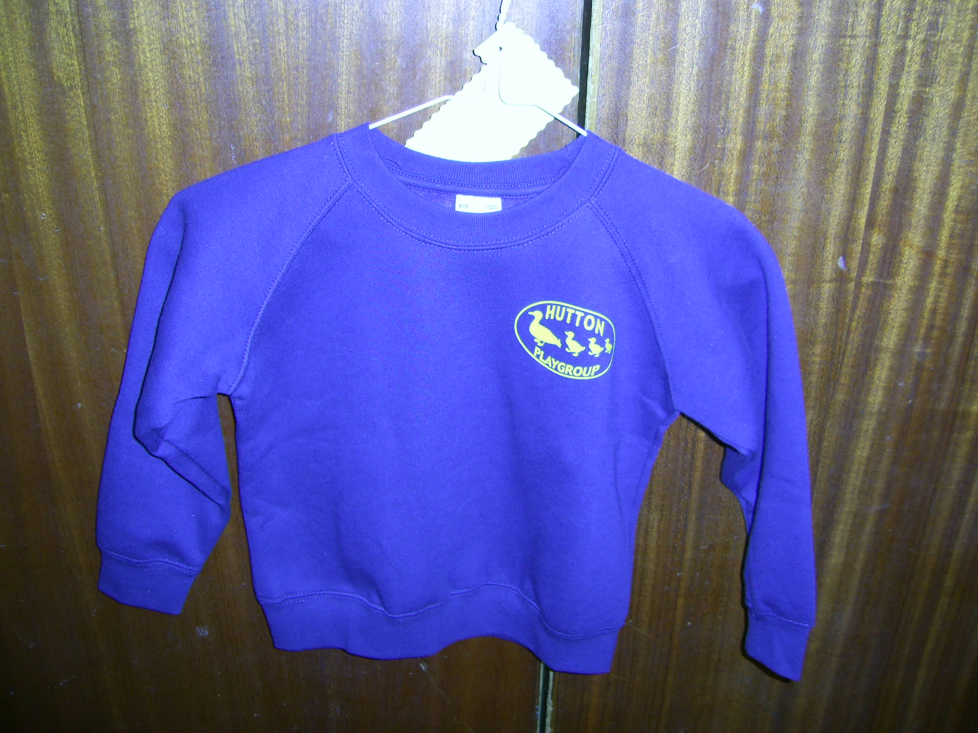

Policies
Our staff can explain our policies and procedures to you. Copies of which are available on the website or a hard copy at Playgroup.
Our policies help us to make sure that the service we provide is of high quality and that being a member of the setting is an enjoyable and beneficial experience for each child and her/his parents.
Our staff and parents work together to adopt the policies and they all have the opportunity to take part in the annual review of the policies. This review helps us to make sure that the policies are enabling our setting to provide a quality service for its members and the local community.

Information we hold about you and your child
We have procedures in place for the recording and sharing of information [data] about you and your child that is compliant with the principles of the General Data Protection Regulations (2018) as follows:
The data is we collect is:
- processed fairly, lawfully and in a transparent manner in relation to the data subject [you and your family]
- collected for specified, explicit and legitimate purposes and not further processed for other purposes incompatible with those purposes
- adequate, relevant and limited to what is necessary in relation to the purposes for which data is processed
- accurate and, where necessary, kept up-to-date
- kept in a form that permits identification of data subjects [you and your family] for no longer than is necessary for the purposes for which the personal data is processed
- processed in a way that ensures appropriate security of the personal data including protection against unauthorised or unlawful processing and against accidental loss, destruction or damage, using appropriate technical or organisational measures
When you register your child with us, we will provide you with a privacy notice that gives you further details of how we fulfil our obligations with regard to your data.
Safeguarding children
Our setting has a duty under the law to help safeguard children against suspected or actual ‘significant harm’. Our employment practices ensure that people looking after children are suitable to fulfil the requirements of their role and help to protect children against the likelihood of abuse in our setting and we have a procedure for managing complaints or allegations against a member of staff.
Our way of working with children and their parents ensures that we are aware of any problems that may emerge and can offer support, including referral to appropriate agencies when necessary, to help families in difficulty.
Special educational needs
To make sure that our provision meets the needs of each individual child, we take account of any special educational needs a child may have. We work to the requirements of the Special Educational Needs and Disability Code of Practice: 0 to 25 years (2015).
Our Special Educational Needs Co-ordinator is | Rose Barnish

The management of our setting
Our setting is a charity and as such is managed by a volunteer management committee - whose members are elected by the parents of the children who attend our setting. The elections take place at our Annual General Meeting. The committee make up the registered person with Ofsted and are responsible for:
- managing our finances
- employing and managing our staff
- making sure that we have, and work to, policies that help us to provide a high-quality service
- making sure that we work in partnership with parents
The Annual General Meeting is open to the parents of all the children who attend our setting. It is our shared forum for looking back over the previous year's activities and shaping the coming year's plan.
Our setting has a parent committee group. This group is made up of, and elected by, the parents of the children who attend the setting. We share with this group, some of the tasks involved in managing the setting.
Fees
The fees are £13.50 payable half-termly in advance. Fees must still be paid if children are absent without notice for a short period of time. If your child has to be absent over a long period of time, talk to Rose Barnish or Sue McGarrie.
- For your child to keep her/his place at our setting, you must pay the fees. We are in receipt of nursery education funding for two-, three- and four-year-olds; where funding is not received, then fees apply. For those entitled to the 15 hours free early years education funding, these hours can be used between 9.00am and 12.00pm on Monday, Tuesday, Wednesday, Thursday and Friday.
- Fees are payable each half term in advance.

We do offer reduced rates, where siblings attend at the same time, so please ask for further details.
As our fees are as low as possible, we are unable to give refunds for holidays or short term illnesses.

Starting at our setting
The first days
We want your child to feel happy and safe with us. To make sure that this is the case, our staff will work with you to decide on how to help your child to settle into the setting.
We hope that you and your child enjoy being members of our setting and that you both find taking part in our activities interesting and stimulating. Our staff are always ready and willing to talk with you about your ideas, views or to respond to any questions.
Settling in
You can help your child to settle in by:
- Staying on the first day, and for as many after that as you need
- Showing them the activities and helping them to learn the names of their key worker and some of the children
- Helping them to be confident about the routine, and that every child is collected at the end of the session.
Separation is a very big step for a child and, if they are finding it difficult, then you may just leave them for a short while (or even just to help in the kitchen).

Once you have decided that they are ready to be left:
- A quick goodbye is best
- Please don’t slip out without telling your child and staff
- Stress that you will be back to collect them later
- Please feel free to peep through the window at any time, or to ‘phone the hall on 612806 for an update
- Please be assured that we will ‘phone you if we feel that a child is excessively upset or not coping.

